0. Maintenance
#Tar the latest version of the scripts
rm utils.tar.gz
tar cvzf utils.tar.gz ./scripts

#Ensure that the latest utils.tar.gz is copied over
ansible-playbook ansible/playbook_cert.yml -i ansible/hosts --tags "deldir,updateutils" --list-tags --list-hosts

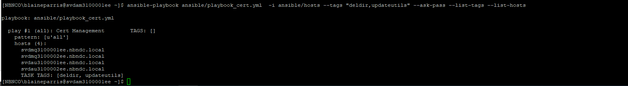

ansible-playbook ansible/playbook_cert.yml -i ansible/hosts --tags "deldir,updateutils" --ask-pass

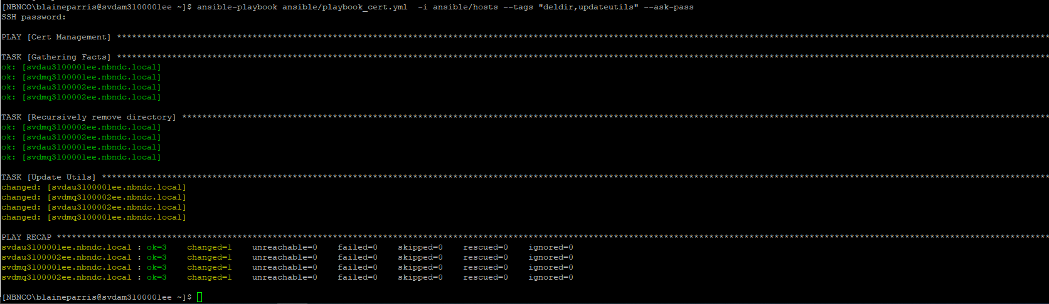

Verify Variables are set correctly
#List Variables used
ansible-playbook ansible/playbook_cert.yml -i ansible/hosts --tags "printvars" --ask-pass
ansible-playbook ansible/playbook_cert.yml -i ansible/hosts --tags "printvars" ---ask-become-pass --ask-pass

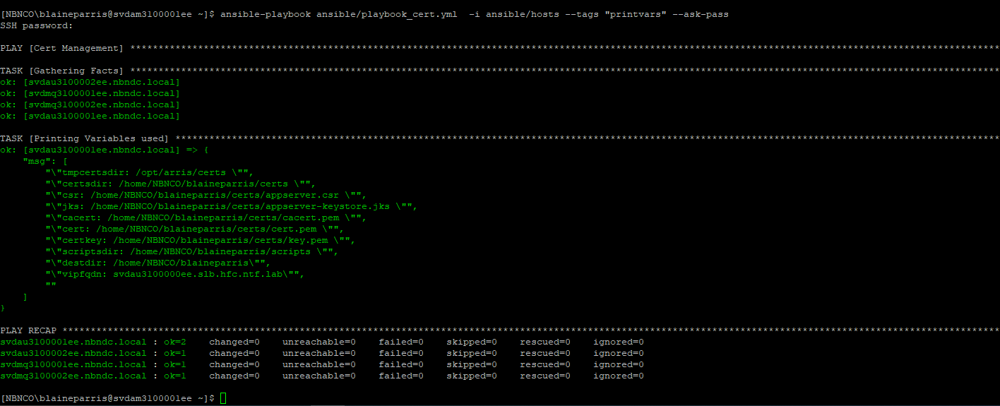

2. Create Keystore - Run against hosts=kscerts **DO NOT RERUN
ansible-playbook ansible/playbook_cert.yml -i ansible/hosts -l kscerts --tags "printvars,createkeystore,genkssancsr " --list-tags --list-hosts

ansible-playbook ansible/playbook_cert.yml -i ansible/hosts -l kscerts --tags "printvars,createkeystore,genkssancsr" --ask-pass
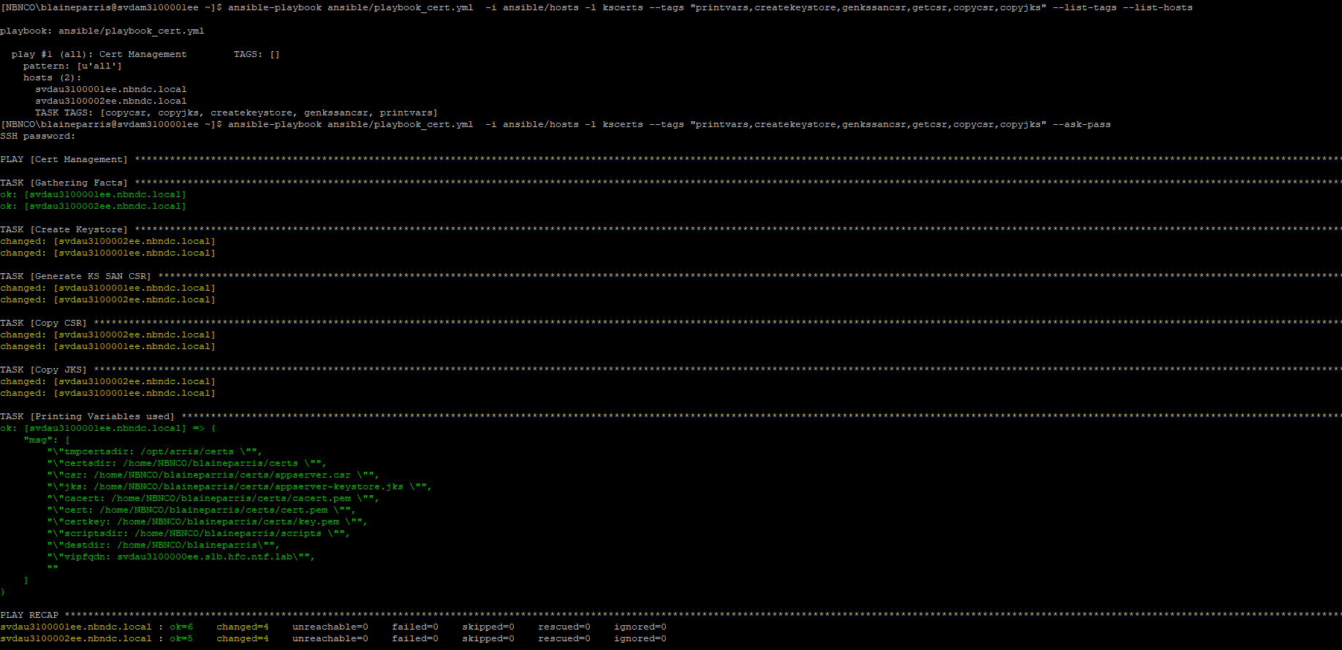
Copy the Certs and JKS across - Run against hosts=kscerts
ansible-playbook ansible/playbook_cert.yml -i ansible/hosts -l kscerts --tags "printvars,copycsr,copyjks" --list-tags --list-hosts
ansible-playbook ansible/playbook_cert.yml -i ansible/hosts -l kscerts --tags "printvars,copycsr,copyjks" --ask-pass

ls -ltrR remotecert/
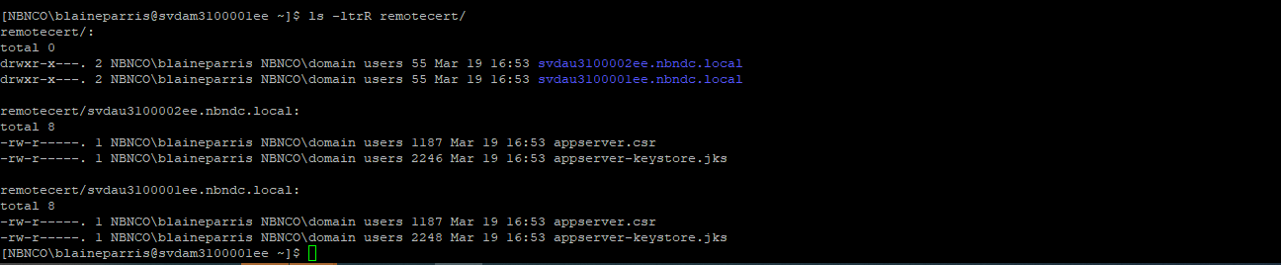
openssl req -noout -text -in remotecert/svdau3100001ee.nbndc.local/appserver.csr| egrep "DNS|Subject"
openssl req -noout -text -in remotecert/svdau3100002ee.nbndc.local/appserver.csr| egrep "DNS|Subject"

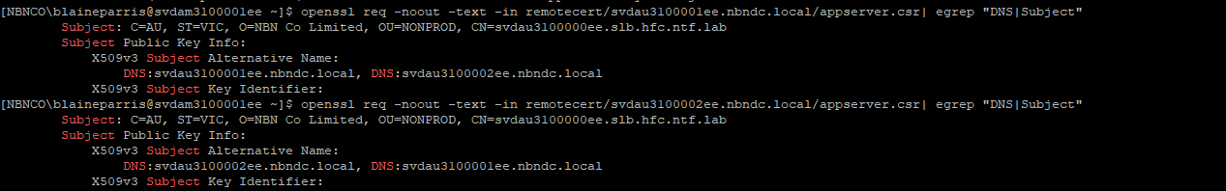

#Check Syntax
ansible-playbook ansible/playbook_cert.yml -i ansible/hosts --tags "printvars" --syntax-check
ansible-playbook ansible/playbook_cert.yml -i ansible/hosts --syntax-check

2. Create OS Private Key - Run against hosts=oscerts ** DO NOT RERUN
ansible-playbook ansible/playbook_cert.yml -i ansible/hosts -l oscerts --tags "printvars,genoscsr" --list-tags --list-hosts
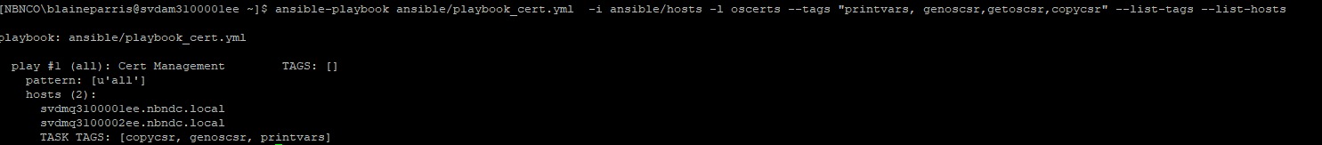
ansible-playbook ansible/playbook_cert.yml -i ansible/hosts -l oscerts --tags "printvars,genoscsr" –ask-pass

ansible-playbook ansible/playbook_cert.yml -i ansible/hosts -l oscerts --tags "printvars,copycsr,copykey" --list-tags --list-hosts

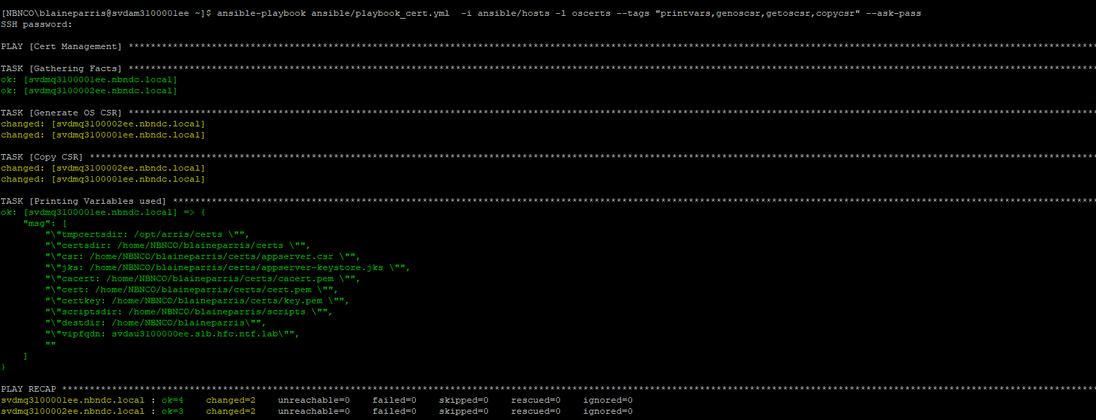

ansible-playbook ansible/playbook_cert.yml -i ansible/hosts -l oscerts --tags "printvars,copycsr,copykey" –ask-pass

ls -ltrR remotecert/
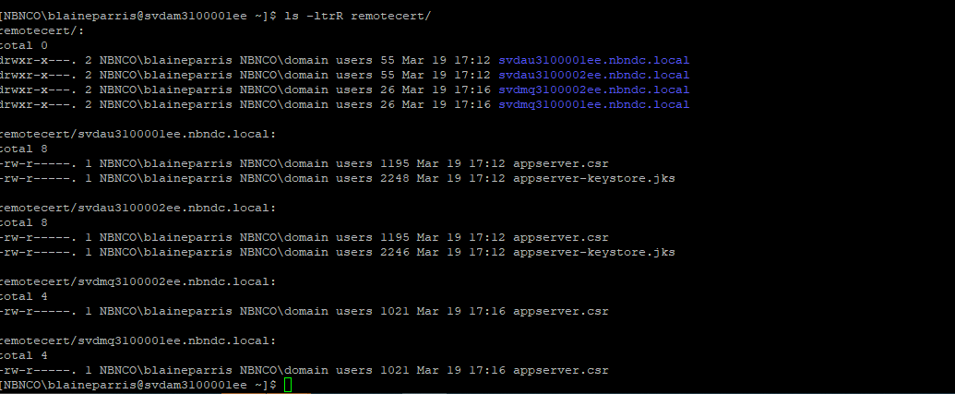

openssl req -noout -text -in remotecert/svdmq3100001ee.nbndc.local/appserver.csr| egrep "DNS|Subject"
openssl req -noout -text -in remotecert/svdmq3100002ee.nbndc.local/appserver.csr| egrep "DNS|Subject"

